Nanny Bears Nursery Menu 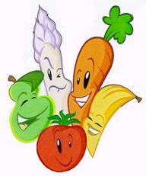
Week One | Monday | Tuesday | Wednesday | Thursday | Friday
Breakfast | Selection of Cereals, Toasts with Honey, Lemon Curd or Jam
Snack | Bananas and Pear | Apples and Oranges | Cheese and Tomatoes | Bananas and Pear | Mixed Fruit
Lunch | Chicken Casserole, Toasted Bread Rolls | Shepherd’s Pie served with Vegetables and Yorkshire Puddings | Lasagne with Veg and Garlic Slices | Corn beef Pie with Veg, Roast Potatoes and Gravy | Fish Fingers served with peas and chipped potatoes
Dessert | Cake and Custard | Rice Pudding | Homemade Biscuits or cakes | Jelly and Custard | Fruit Crumble
Tea | Spaghetti on Toast Sandwich | Cheese and tomato pizza | Wraps served with tuna or cheese and tomato | Vegetable soup served with a bread roll | Selection of Ham and cheese Sandwiches
Dessert | Strawberry Mouse | Fairy Cake | Fruit Scones | Swiss Roll | Flavoured Mouse

Individual dietary needs can be catered for please ask staff for details. Babies Fruit pots and Yogurts if they cannot eat the Snack

