Nanny Bears Nursery Menu 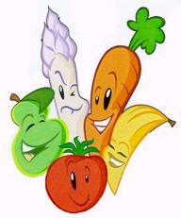
Week Three | Monday | Tuesday | Wednesday | Thursday | Friday
Breakfast | Selection of Cereals, Toasts with Honey, Lemon Curd or Jam
Snack | Cucumber and Cheese | Mixed Fruit | Apples and Oranges | Cheese and Tomatoes | Apples and Bananas
Lunch | Steak Pie with Vegetables, Roast Potatoes and Gravy | Pasta in Creamy Cheese Sauce and Seasoned Vegetables | Vegetable Casserole with Crusty rolls | Cottage Pie with Yorkshire puddings and Gravy | Fish Bites with beans and chipped potatoes
Dessert | Fruit Crumble | Homemade Sponge and Custard | Rice Pudding | Jelly and Custard | Flavoured Mouse
Tea | Cheesy Beans on Toast | Vegetable Soup and Crusty Buns | Mixed Topping Pizza | Hotdog Buns with Tomato Sauce and Onions | Wraps served with cheese and Ham
Dessert | Mixed Fruit Salad | Homemade Biscuits | Strawberry Mousse | Jelly and Yoghurt | Sponge Cake

Individual dietary needs can be catered for please ask staff for details. Babies Fruit pots and Yogurts if they cannot eat the Snack

