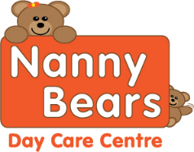 Nanny Bears Nursery Menu 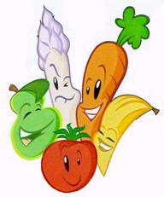
Week two | Monday | Tuesday | Wednesday | Thursday | Friday
Breakfast | Selection of Cereals, Toasts with Honey, Lemon Curd or Jam
Snack | Apples and Oranges | Cheese and Tomatoes | Bananas and Pears | Mixed Fruit | Cucumber and Cheese
Lunch | Mince and Dumplings with Veg, Yorkshire puddings and Gravy | Beef Casserole with Crusty Rolls | Cheese and Bean Pie with Roast Potatoes and Gravy | Tomato and Garlic Pasta with Vegetables and Garlic Bread | Fish cakes, Potatoes and Vegetables
Dessert | Rice Pudding | Sponge and Custard | Fruit Crumble | Flavoured Mouse and Jelly | Swiss Roll
Tea | Bean and Sausage on Toast | Bread Buns with a selection of fillings | Wraps with tuna or Ham | Cheesy Waffles and beans | Vegetable soup served with a bread roll
Dessert | Mixed Fruit Salad | Chocolate rolls | Chocolate Mousse | Biscuits | Jelly and Yoghurt

Individual dietary needs can be catered for please ask staff for details. Babies Fruit pots and Yogurts if they cannot eat the Snack

