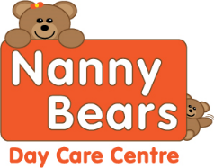V=Vegan DF = Diary Free SF=Sugar Free Nanny Bears Nursery Week Menu 3 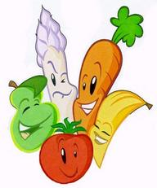
Week Three | Monday | Tuesday | Wednesday | Thursday | Friday
Breakfast | Selection of Cereals, Toasts with Honey, Lemon Curd or Jam Water and Milk available all day
Snack AM | Pear and Apple | Melon Slices | Cheese and Tomatoes | Orange and apple | Pears and Bananas
Starter | Flat Bread |  |  | Garlic Bread
Lunch | Jerk Chicken with savoury Rice | Shepherd’s Pie with Vegetables and Gravy  Quorn mince V | Chicken and Leek Pie with mixed vegetables | Spaghetti Bolognaise with vegetables DF  Quron mince V | Fish cakes, potato croquettes and mushy peas  Veggie Burgers V, DF
Dessert |  | Apple Pie with optional SF custard | SF Jelly and mixed fruit |  | Banana and SF Custard
Snacks PM | Oat Cakes | Carrot Sticks | orange and apple | Cucumber sticks | Rice Cakes
Tea | Pizza and Beans  Vegan Pizza DF | Veggie sticks and Bean V | Red lentil soup with a crusty roll DF,V | Assorted Wraps, DF  V spread | Tomato and basil penne pasta with sweetcorn and cucumber
Dessert | Mixed Fruit Platter | Oats, bananas and natural yogurt | Peaches and Cream | Oaty Biscuit | Frozen Fruit natural yogurt
Although our food is prepared with care, due to handling allergens in our kitchen. We cannot guarantee it will be allergen free, even after the ingredients have been removed on request. All desserts for Vegan, Diary Free and other preferenaces are swapped for an alternative option
For Individual dietary please ask a member of staff for further information. Babies under 1 are given softer healthy options for snacks

